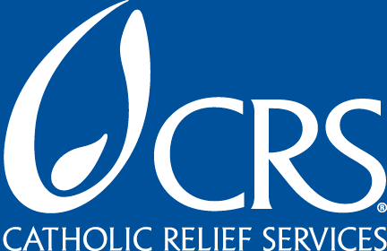
INTERNATIONAL DEVELOPMENT FELLOWS PROGRAM

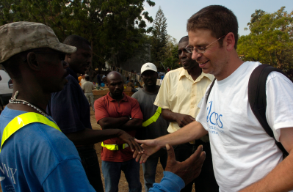
Catholic Relief Services (CRS) is one of the largest humanitarian agencies, serving in more than 90 countries worldwide. We are currently recruiting for our International Development Fellows Program (IDFP) at universities throughout the United States. If you are a graduate student who is interested in entering into a long-term career in International Development and a possible career with CRS, the IDFP might be the program for you.

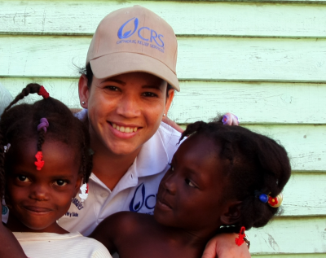
The International Development Fellows Program aims to recruit individuals who desire a career in international development and relief and provides an opportunity to increase their overseas experience and gain broader exposure to CRS programs. Assignments are for one year and fellows work abroad in areas of agriculture, health, peace building, education, microfinance, and HIV and AIDS. The goal of the IDFP is to place Fellows in positions where they can draw on their previous education and work experience, while broadening their skills. Many of our fellowships lead to regular positions with Catholic Relief Services.

We are looking for students with:
- International experience
- Interest in working for a faith-based organization
- Masters Degree: International Affairs, Community Development, Agriculture, Public Health, Education, etc.
- Professional proficiency in French, Spanish, Arabic or Portuguese
- Strong cross-cultural skills

For more information and to apply for our fellowship, please go to our website at www.crs.org/fellows.
For questions and for more information, please e-mail us at idfp@crs.org.

